***Lab 7.2- Code First Approach with Entity Framework using Stored Procedure***

*Create an Empty MVC Application.*

*Add an Employee class in Model Folder:*

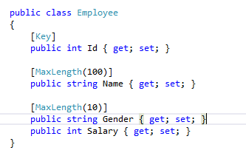

*Create Folder > Name = Context > Right click on the context folder > Add > Class > Name = EmployeeDBContext*

**

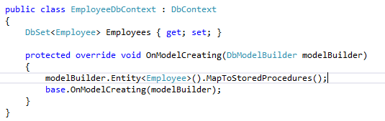

*Please note if you get an error while importing the namespace* ***using System.Data.Entity*** *please install Entity Framework from nugget.org*

*Build the solution:*

*Add a Controller: Right click on Controllers Folder > Add > Controller*

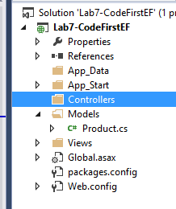

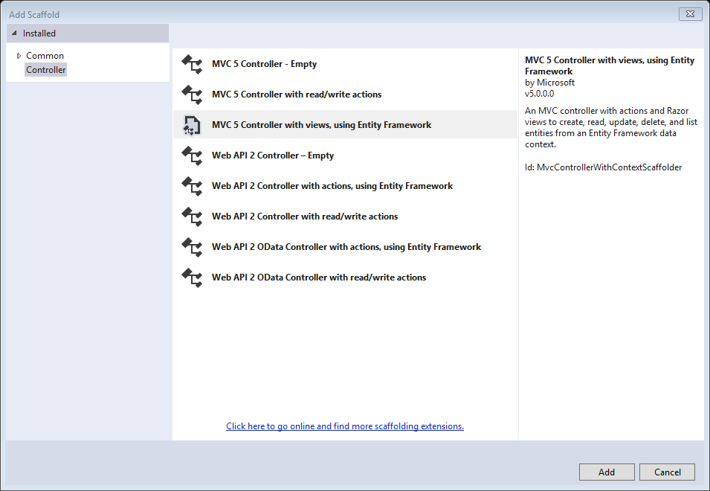

*Select MVC 5 Controller with views, using Entity Framework > Click on Add button*

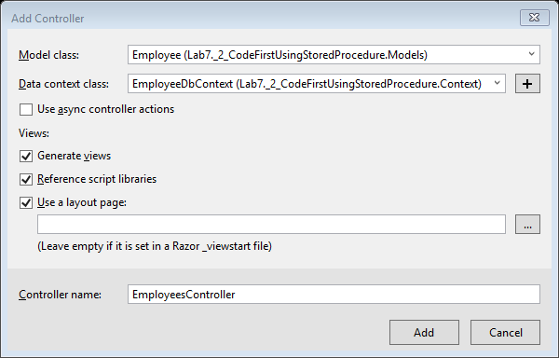

*Select the following as show in the above image: Model class = Employee class > Data Context class: EmployeeDbContext > Controller Name = EmployeesController > Click on Add button*

*Now add the following code in web.config:*

<connectionStrings>

<add name="EmployeeDbContext"

connectionString="Data Source=(localdb)\v11.0; Initial Catalog=EmployeeContext-20160314191434; Integrated Security=True; AttachDbFilename=|DataDirectory|EmployeeContext-20160314191434.mdf"

providerName="System.Data.SqlClient" />

</connectionStrings>

*Run the code and the database will be created.*

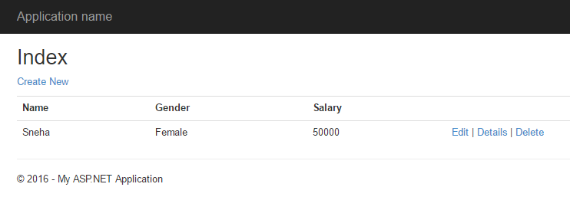

*Now if we check the server explorer.*

